## [Image Files](https://www.testdome.com/questions/bash/image-files/87985)

You ran a script that wrongly put its output image files in the 'work' directory inside the current directory.

Create a bash script that removes all the files in the 'work' directory that start with either 'out_0' or 'out_1' and end with '.png'.

For example, if the 'work' directory contains the following files:

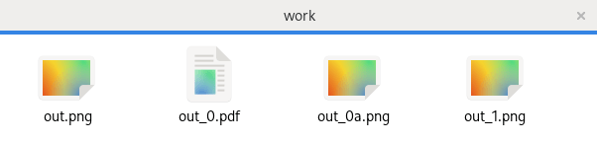

After running your script, both out.png and out_0.pdf should exist in the 'work' directory but out_0a.png and out_1.png should no longer exist.

See the [example case](https://www.testdome.com/resources/media/6838da9e-1db2-45d7-a710-67af5dfa6a39/work.sh) for more details.